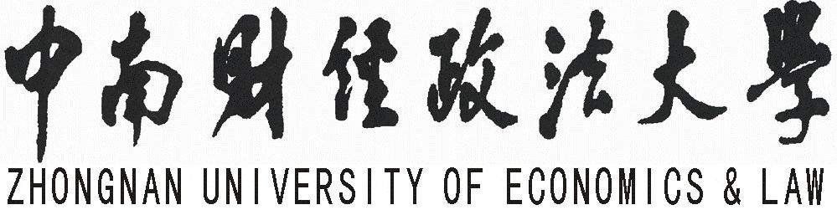

Education Certificate

Name |  | Gender |  | Birthplace
School | Criminal Justice | Major | Criminal Law
Registration No. | 14118118000 | Citizen ID | 410105111111111111

This is to certify that Li Rui is now studying in the graduate program at Zhongnan University of Economics and Law and his/her student number is _____. He/She has been enrolled in the School of Criminal Justice, majoring in Criminal Law from September 2014 to present and has finished all the required degree-courses in this program. He/She will be awarded the degree of Master of Laws in June 2017.
This certificate is used for his/her application for ________.
The School of Criminal Justice
of Zhongnan University of Economics and Law
Nov. 1st 2016

地 址: 湖北省武汉市东湖高新技术开发区南湖大道182号 邮 编:430073

